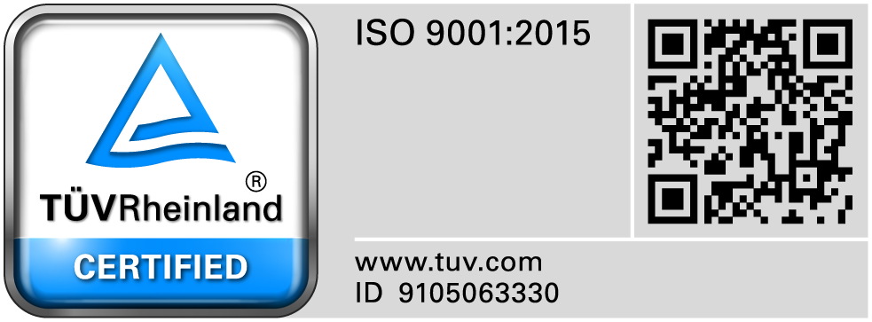**SRI RAMAKRISHNA ENGINEERING COLLEGE**

[Educational Service: SNR Sons Charitable Trust]

[Autonomous Institution, Accredited by NAAC with ‘A’ Grade]

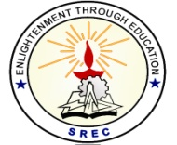[Approved by AICTE and Permanently Affiliated to Anna University, Chennai]

[ISO 9001:2015 Certified and all eligible programmes Accredited by NBA]

Vattamalaipalayam, N.G.G.O. Colony Post, Coimbatore – 641 022.

**DEPARTMENT OF COMPUTER SCIENCE AND ENGINEERING**

**ACADEMIC YEAR : 2020-2021(ODD)**

**CLASS: II CSE A, B & C SEMESTER: 03**

**BATCH: 2019-2023**

**Capstone Project List**

1. Blood donation system
2. Book Store Management System
3. College Automation System
4. College E-Lecturer annotation
5. College Report Handling System
6. Examination Result Analysis System
7. Internet Based Live Courier Tracking and Delivery System
8. Inventory Management System
9. Library Management System
10. Municipal Corporation Complaint Management System
11. Library Management System
12. Online Examination System
13. Online Personal Counselling system
14. School Event and Attendance Management process
15. Campus Selection System
16. Cool cab service
17. Sports Event Management System
18. E-Election voting system
19. Result Analysis Management
20. Vehicle management system
21. Student Information Management System
22. Bus seat Allocation System
23. Payroll Processing System
24. Ticket Management System
25. Hospital Management System
26. Calculator Application

**Course Coordinators HOD-CSE**

**Dr. A. Grace Selvarani, AP/CSE**

**Mrs. S. Ezhilin Freeda, AP/CSE**

**Mr. G. Narendran, AP/CSE**